**Documentation - Supply Chain Game**

1. **Connecting Raspberry Pi to Wi-Fi: Bayern@WLAN**

* Browser

hotspot.vodafone.de/Bayern

* If it does not work:
  + Open terminal: sudo date --set 'JJJJ-MM-TT HH:MM:SS‘ (type in the current date and time)
  + Try connection again

1. **Updating Raspberry Pi**
   * Terminal

sudo apt-get update

sudo apt-get upgrade

1. **Download Git-Repository (if it not exists on the desktop)**
   * Terminal: cd Desktop (or Schreibtisch)
   * Terminal: git clone https://github.com/IoTLabHNU/SCGame
2. **Installing RFID-Modul**
   * GPIO Assignment:

|  |  |
| --- | --- |
| RFID-Reader | Raspberry Pi |
| VCC | GPIO 1 (3V Power) |
| RST | PIN 22 (BCM 25) |
| GND | PIN 6 (Ground) |
| MISO | PIN 21 (BCM 9) |
| MOSI | PIN 19 (BCM 10) |
| SCK | PIN 23 (BCM 11) |
| NSS | PIN 24 (BCM 8) |
| IRC | / |

1. 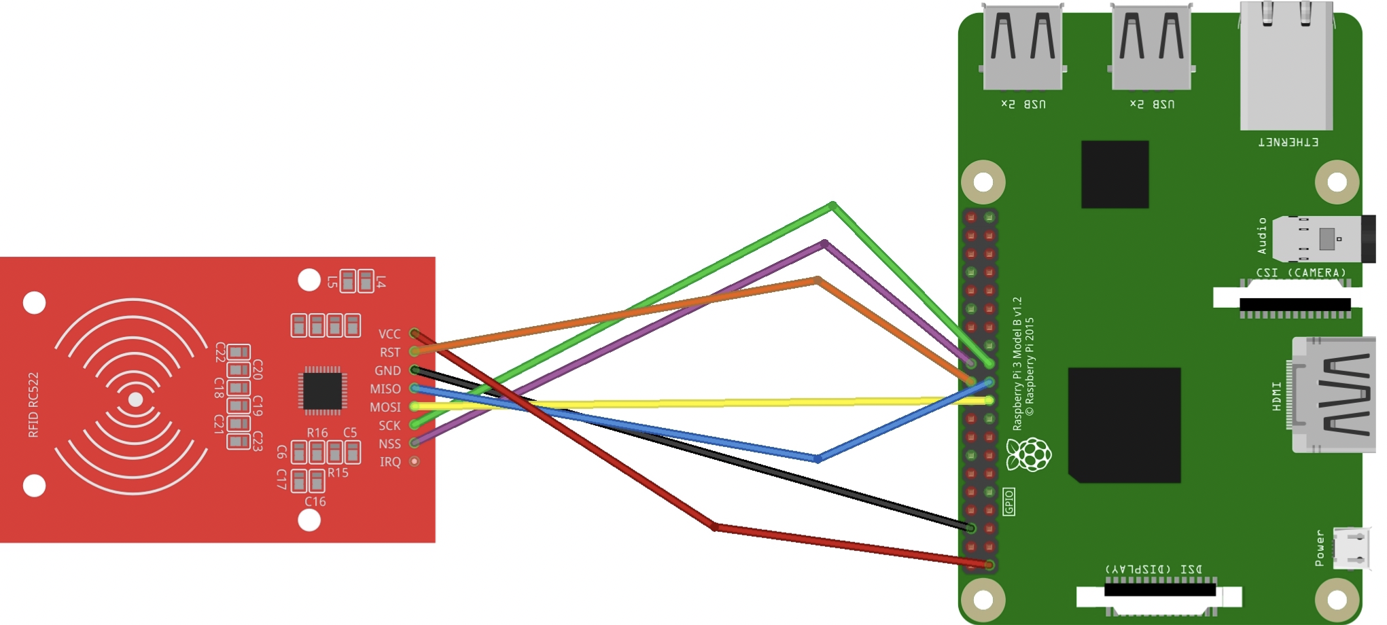**Circuit diagram**
2. **SPI**
   * Activate SPI:

sudo raspi-config

interfacing options – SPI – enable

sudo reboot

* + Updating Config-file

sudo nano /boot/config.txt

dtparam=spi=on (add at the end of the file)

* + Installing RFID-Reader

sudo apt-get install python3-dev python3-pip sudo pip3 install spidev

sudo pip3 install mfrc522

* + Test RFID-Reader:

Open: Read.py or Write.py

1. **Installing MySQL-Server on rp-admin**

* Terminal

sudo apt-get install mysql-server

sudo mysql -u root -p

enter password: root

create user ‚pi‘@‚%‘ identified by ‚pi’;

grant all privileges on *.* to ‚pi‘@‚%‘ with grant option;

flush privileges;

exit

1. **Bind-Adress**
   * Terminal:

sudo nano /etc/mysql/mariadb.conf.d/50-server.cnf

Change Bind-adress to 0.0.0.0

strg + o

strg + x

1. **Change name of all Raspberry PIs**

* Terminal:

sudo nano /etc/hostname

change name to:

rp-admin

rp-team1

rp-team2

rp-team3

rp-team4

strg + o, enter

strg + x

* Terminal

sudo nano /etc/hosts

change name to:

rp-admin

rp-team1

rp-team2

rp-team3

rp-team4

stag + o

strg + x

* Reboot

sudo reboot

1. **Installing MySQL Database Driver**

* Terminal

sudo apt-get install python-mysqldb

sudo python -m pip install mysql-connector